[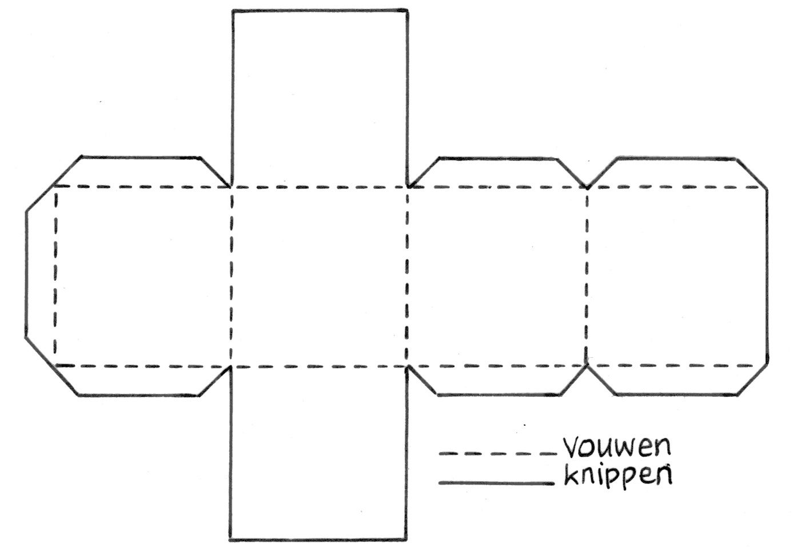](https://www.google.nl/url?sa=i&url=https%3A%2F%2Fwww.bijbelgenootschap.nl%2Falef%2Fallenummers%2Fjuliaugustus-2016%2F&psig=AOvVaw3NBjKmM5H4glKzfNeHFfDC&ust=1584527704913000&source=images&cd=vfe&ved=0CAIQjRxqFwoTCNjgkOqnoegCFQAAAAAdAAAAABAE)